Amarzaya Sonomdagva (Amuna)

Trade and Foreign Aid in Latin America

Professor Maluccio

Final Research Paper

**Did the 2019 estallido social lead to divergent shifts in institutional trust, democratic support, and economic outlook across socioeconomic, geographic, age and ideological groups in Chile?**

# Introduction

Chile’s rapid economic growth from the 1980s through the early 2000s is often referred to as one of Latin America’s economic miracles. This economic success is largely attributed to its embrace of neoliberalism, with extensive trade liberalization, privatization, and minimal government intervention. Distinguished economists, such as Gary Becker, praised Chile’s market-oriented reforms as a model for developing nations (Kaiser, 2020). It is currently a high-income country with a GNI per capita of $15,800 (current US$), higher than Mexico ($11,980) and China ($13,390) as of 2023 (World Bank, 2023). However, Chile remains a highly unequal society, a stark reality revealed by the nation-wide social protests in 2019 after the government decided to increase the per metro fare by four percent (Edwards, 2023). Although this hike is equivalent to only thirty pesos, or approximately four U.S. cents, it triggered the largest scale protest in the country’s democratic history. This event raises a critical question: how did a booming, high-income nation celebrated as a successful economic model face such widespread intense public discontent over a relatively minor policy change?

Mass mobilization signals public willingness to hold authorities accountable and speaks to a society where civic engagement is alive. Chile’s democracy has consistently scored between 7 and 8 out of 10 in the Economist Intelligence Unit’s Democracy Index, a level comparable to the United States and France, even in the face of multiple large-scale protests since the country’s transition to democracy in the 1990s (EIU, 2024). But large-scale protests also reflect a deeper disconnect between citizens and the state, particularly when they occur amid strong economic performance. The 2019 protest began when high school students began evading metro fares, recording themselves on social media jumping turnstiles. Their actions quickly gained momentum and captured national attention (Chacón, 2020). By October 25, 2019, an estimated 1.2 million Chileans gathered in Santiago to protest (Vergara & Luna, 2019). President Sebastián Piñera responded by declaring a state of emergency and deploying the military, a move not seen since the dictator leader Pinochet’s regime. Human rights organizations, including Amnesty International and Human Rights Watch, reported widespread abuses of harmful ammunition, such as use of tear gas, rubber bullets, and excessive force left over 12,000 people injured (Amnesty International, 2020).

This research paper investigates how Chileans’ attitudes toward democracy, economic conditions, and institutional trust shifted before and after the 2019 estallido social. I hypothesize that the groups most actively involved in the protests, particularly younger, urban, left-leaning, and lower-income citizens would show more negative shifts in their perceptions of democracy, institutional trust, and both personal and national economic outlook. These groups were not only more likely to mobilize, but also affected by the policy failures that fueled discontent. In contrast, citizens who were less engaged or shielded from the direct consequences of these events may have experienced relatively stable or even improving outlooks.

# Overview of potential causes

Chile has succeeded in achieving economic measures that many countries dream about, yet inequality remains a serious problem. From 1970 to 2023, Chile’s GDP grew 36 times from $9.14 billion to $335.53 billion (current US$) (World Bank, 2024). Chile substantially reduced extreme poverty since its implementation of neoliberal policies. By the late 1980s, over 60% of the total population was living under the poverty line ($6.85 a day (2017 PPP)), but it is reduced to 5% as of 2022 (World Bank, 2024). Much of this Chile’s rapid economic growth is credited to policies introduced under Augusto Pinochet’s dictatorship, which aggressively privatized state-owned enterprises. ​​​​His privatization shock therapy swiftly formed a group of elites who bought off previously nationalized companies thanks to their close relationship with Pinochet. His privatization efforts are often criticized for benefiting a few elites without creating true competition (Bevins, 2023).

In contrast to these macroeconomic gains, income inequality remains high, with a GINI index of nearly 43 (World Bank, 2022). While it is true that the GINI index has been on the decline over the past 35 years, it is improving at a much slower rate compared to its economic growth. This paradox signals significant wealth disparity in Chilean society and indicates that national wealth has not trickled down through society. In addition, widespread public frustration suggests that economic growth alone may not translate into perceived well-being.

Several large-scale protests in the past two decades have exposed growing dissatisfaction with inequality and the limits of market-based reforms. One of the first major post-democratization protests, the 2006 Penguin Revolution, centered on how privatization of education increased costs while failing to provide quality education (Cabalin, 2012). Protesters dressed in black and white, the colors of their school uniforms which gave the movement its name, the “Penguin Revolution,” demanded better funding for public education. Similarly, in 2011, both high school and university students mobilized again, calling to dismantle the heavily privatized, exclusive education system and demanding provision of free, quality higher education for all. These movements represent a broader critique of structural inequality and the failure of privatized public services to meet basic needs (Nugent, 2020).

Chile is not unique in this paradox of growing economic growth and public dissent. To take the Arab Spring as a simple example, a similar large-scale protest was mostly ignited by socioeconomic inequality. Regardless of how strongly people supported protests themselves, 63% of nationally representative survey respondents in Tunisia chose economic problems as the top reason for mass mobilization. This study sheds light on how Tunisia’s economic performance was not weak prior to the protest, but instead reveals that citizens did not feel they were benefitting from the country’s growing wealth, which is also comparable to Chile’s internal situation (Ghanem, 2016). A study conducted by the Center for Public Studies during the timeline of the 2019 protests also found that 55% of respondents chose inequality as the country’s top problem (Cox et al., 2024). Given that the two major protests preceding 2019 were also rooted in unequal access to public goods like education, the estallido appears to reflect frustration with structural inequality, but not necessarily a reaction to worsening economic conditions. In other words, Chile is not collapsing economically. Rather, the private-sector-driven model of distributing public goods such as pensions and education is failing to meet the expectations of a society that increasingly demands equity, dignity, and inclusion.

The 2019 estallido was not an isolated event, but part of this broader pattern. This paper builds on that context by examining whether and how these frustrations translated into shifts in public attitudes toward democracy, the economy, and trust in institutions following the 2019 protests.

# Methodology

This study uses data from the Latinobarómetro, a regional public opinion survey conducted annually across 18 Latin American countries. The survey covers a wide range of political, economic, and social topics and includes a nationally representative sample of approximately 1,200 respondents in Chile.

To evaluate how public attitudes shifted before and after the 2019 estallido social, I apply a Differences-in-Differences (DiD) framework. This method allows for a comparison between groups that were more likely to be affected by the protests and those that were not, helping to isolate the relative impact of the protest period on key political and economic attitudes.

The treatment group consists of individuals who were likely more affected by the metro fare hike and the broader social unrest. This includes younger, left-leaning, lower-income, and urban residents who were more likely to have felt excluded from Chile’s economic and political systems and to have experienced changes in attitudes following the protests. The control group includes those relatively less affected, such as older, right-leaning individuals, those in higher income brackets, and rural residents. The analysis compares changes in attitudes across these groups from 2018 (pre-protest) to 2023 (post-protest), focusing on four outcome variables: trust in government institutions, trust in non-government institutions, support for democracy, and economic outlook (both personal and national).

These variables were selected to reflect the underlying grievances that drove the protests. Trust in institutions is a key indicator given the widespread discontent expressed toward political leadership. I distinguish between government and non-government institutions to assess whether the shift in trust was specific to the political system or part of a broader erosion in social trust. This is particularly important considering the large scale of the protests and the disruption they caused across Chilean society. The slogan “It’s not about 30 pesos; it’s about 30 years” was a popular one in the protest. It captured the public’s frustration with the country’s democratic legacy, which motivated me to look at attitudes toward democracy. Economic outlook was chosen to capture how people perceive inequality and whether economic expectations shifted following the estallido. This research design helps determine whether exposure to or engagement with the 2019 protests led to significant shifts in public opinion along these key dimensions.

I identified identical questions from the 2018 and 2023 surveys, combined the two datasets, and standardized the outcome variables to account for differences in scale. I then created indices by averaging standardized responses. I ensured responses such as “not at all satisfied” and “the country is in decline” were treated as being on the same end of the spectrum, so that higher values consistently reflect greater optimism and excluded “Don’t know” and missing responses to ensure comparability across years.

*Regression Model:*

* Outcome refers to one of the key dependent variables: *trust in institutions*, *support for democracy*, or *economic outlook*
* Post is a binary variable indicating the post-treatment period (1 if year = 2023, 0 if year = 2018)
* Group is the treatment variable of interest, such as socioeconomic class, age group, region, or political ideology
* Post × Group captures the interaction effect, identifying the differential change in the outcome for the treatment group after the 2019 protests
* X is a vector of control variables (e.g., sex, education, religion, race)
* εit is the error term

# Results

## Socioeconomic Differences in Economic Attitudes, Democratic Support, and Institutional Trust

*How did the perceived economic outlook change between 2018 and 2023 across different socioeconomic classes?*

In 2018, lower-middle and lower-class respondents were significantly less optimistic about the economy than the upper class, by 0.41 and 0.53 SD respectively. Support for democracy and trust in government institutions followed similar patterns, with both lower socioeconomic groups reporting substantially lower values than the upper class. For example, lower-middle-class respondents were 0.29 SD less supportive of democracy and 0.44 SD less trusting of government institutions.

Between 2018 and 2023, economic optimism among the upper class declined by 0.49 SD. In contrast, the lower-middle and lower classes became relatively more optimistic, with increases of 0.23 SD (p = 0.04) and 0.21 SD (p = 0.10), respectively. Democratic support followed the same pattern: the upper class experienced a 0.38 SD drop in 2018, while the lower-middle and lower classes became 0.22 and 0.24 SD more supportive of democracy compared to the upper class in the later period.

In 2018, middle-class respondents expressed less trust in government institutions than their upper-class counterparts by 0.28 SD (p = 0.013). Similarly, both the lower-middle and lower classes reported substantially lower trust than the upper class, with differences of 0.44 SD and 0.53 SD, respectively (both p < 0.001).

In 2023, the middle class showed no meaningful change towards trust in government institutions relative to the upper class. The trust increased among the lower-middle and lower classes relative to the baseline (by 0.09 and 0.06 SD, respectively). Though these changes were not statistically significant, they suggest a small rise in confidence in public institutions among lower socioeconomic groups. Trust in non-government institutions such as unions, media, and banks declined only slightly in 2023 (−0.03 SD, not significant). In 2018, trust was significantly lower among the lower–middle (−0.40 SD) and lower classes (−0.53 SD), both with p < 0.01. Over time, all groups exhibited small increases in trust relative to the upper class though none were statistically significant.

## Regional Differences in Economic Attitudes, Democratic Support, and Institutional Trust

*How did the perceived economic outlook change between 2018 and 2023 between urban and rural regions?*

In 2018, urban residents were significantly more optimistic about the economy than rural residents, by 0.13 SD (p < 0.05). Between 2018 and 2023, economic optimism declined by 0.22 SD among rural residents. Among urban residents, the decline was significantly steeper by an additional 0.14 SD (p < 0.05), which resulted in a total drop of 0.36 SD. This indicates that urban economic sentiment deteriorated more sharply over time.

Democratic attitudes followed a similar but weaker trend. In 2023, rural residents expressed 0.14 SD less support for democracy than they had in 2018, a statistically significant drop (p < 0.01). Although urban residents started slightly more supportive relative to the rural population (by 0.04 SD), the additional decline among urbanites was not statistically significant (−0.05 SD, p = 0.27). This indicates that democratic support decreased more clearly among rural populations, while changes in urban areas were less conclusive.

For trust in government institutions, in 2018, urban respondents reported marginally lower trust than rural peers (−0.08 SD), but by 2023, their trust rose modestly relative to rural residents (+0.12 SD), although this was not statistically significant. Trust in non-government institutions followed an almost identical trajectory: small rural–urban differences at baseline, and a modest relative increase in urban trust by 2023 (+0.11 SD), again not significant.

## Generational Differences in Economic Attitudes, Democratic Support, and Institutional Trust

*How did the perceived economic outlook change between 2018 and 2023 across different age groups?*

In 2018, older individuals were significantly more pessimistic than the youngest cohort (19–24), though the 25-34 group was slightly more optimistic than them. Specifically, those aged 55–64 were 0.13 SD less optimistic, and those 65+ were 0.14 SD less optimistic, both statistically significant (p < 0.05). Other age groups did not differ significantly from the baseline. From 2018 to 2023, the baseline economic outlook declined by 0.24 SD. This decline was especially sharp among individuals aged 45–54, whose optimism dropped by an additional 0.21 SD relative to 19–24-year-olds (p < 0.001). Declines for other groups were not significant.

Attitudes towards democracy declined by 0.10 SD between 2018 and 2023 at an insignificant level. However, the drop was much more pronounced among middle-aged groups. Those aged 35–44 and 45–54 showed statistically significant declines of 0.17 SD relative to the youngest group (both p < 0.05). No meaningful changes were found for other age groups.

Trust in government institutions rose by 0.18 SD from 2018 to 2023 (p < 0.05), driven largely by young people. In 2018, trust was already higher among older age groups such as 35–44 relative to the 19-24 group (+0.17 SD, p < 0.05). However, the DD interactions suggest that older cohorts experienced smaller gains or even slight relative declines in trust. For example, those aged 35–64 had interaction terms between −0.15 and −0.17, although not statistically significant. Trust in non-government institutions changed very little over time. The overall change from 2018 to 2023 was small (+0.06 SD) and not significant. None of the age groups showed statistically meaningful differences from the baseline, either in 2018 or over time.

Figure 1 shows that younger adults (especially those aged 19–24) were significantly less trusting of institutions than older groups in 2018. By 2023, however, trust levels became more uniform across age groups. While all cohorts showed some increase in trust, the most noticeable relative gain occurred among the youngest group.

## Political Belief/Ideology Differences in Economic Attitudes, Democratic Support, and Institutional Trust

In 2018, both middle and right-leaning individuals were significantly more optimistic about the economy compared to left-leaning respondents. People in the middle were 0.33 SD more optimistic, while right-leaning individuals were 0.38 SD more optimistic. Similarly, trust in government institutions was 0.44 SD and 0.47 SD higher for middle and right-leaning groups, respectively. Right-leaning respondents also showed stronger support for democracy (+0.13 SD), a statistically significant difference.

However, from 2018 to 2023, economic optimism declined sharply for both middle and right-leaning groups relative to the left-leaning baseline. Specifically, middle respondents saw a 0.52 SD drop (p < 0.01), and right-leaning respondents experienced an even larger decline of 0.71 SD (p < 0.01). This suggests a substantial reversal in economic perceptions among ideologically moderate and conservative Chileans.

Democratic support also declined more among right-leaning respondents, with a significant drop of 0.26 SD (p < 0.01), and to a lesser extent among middle-leaning individuals (−0.13 SD, p < 0.05). This suggests growing democratic dissatisfaction in groups that previously reported stronger support. Trust in government institutions decreased significantly in both groups. Compared to left-leaning individuals, middle and right-leaning respondents became 0.51 and 0.69 SD less trusting, respectively (both p < 0.001). The decline in trust appears especially stark given their initially higher baseline levels in 2018. No statistically significant change was observed in trust in non-governmental institutions for either group, although both middle and right-leaning individuals showed small downward trends. Again, this trend is consistent with previous findings, where government and non-government institutions do not follow the similar patterns.

# Discussion

*Economic Outlook*

Between 2018 and 2023, economic optimism declined most significantly among upper-class Chileans, while lower-income groups showed some improvements. Middle and right-leaning Chileans, who were previously more optimistic, experienced sharp drops in economic outlook, particularly those on the right. Among age groups, middle-aged adults (especially those aged 35–54) became notably more pessimistic, while younger and older Chileans remained relatively stable. Regional differences further reveal that urban Chileans, despite initially higher optimism, saw a larger decline in economic confidence. Altogether, economic perceptions deteriorated the most among groups that had once been more optimistic, such as the affluent, urban, middle-aged, and politically conservative.

*Democratic Attitudes*

Support for democracy weakened across many groups, but the steepest declines were observed among upper-class, middle-aged, and right-leaning Chileans. These groups began with higher levels of democratic commitment in 2018 but experienced noticeable drops in 2023, particularly those aged 35–54 and on the political right. In contrast, lower-income groups showed relative gains in democratic attitudes over time. Regionally, although urban respondents started off more supportive of democracy, the subsequent decline was broadly similar across regions. These results suggest that dissatisfaction with democracy in the post-estallido period was especially acute among the upper-income, ideologically moderate-to-conservative, and middle-aged Chileans.

*Trust in Institutions*

Trust in government institutions increased modestly among lower-income and younger Chileans, despite their more skeptical starting points. These relative gains indicate growing confidence in public institutions among traditionally disadvantaged groups. In contrast, middle and right-leaning respondents, who initially expressed greater trust, experienced the sharpest declines. While young Chileans showed the greatest increases in trust, older adults remained comparatively steady. In terms of residence, institutional trust was stable overall, with urban residents showing slight improvements over time. In contrast, trust in non-government institutions remained relatively low across disadvantaged groups and showed only minor changes across all categories. Unlike government trust, these attitudes remained more entrenched and less responsive to the events of the estallido. The clearest takeaway is that the gains in institutional trust post-2019 were specific to governmental institutions and concentrated among youth and the economically marginalized.

**Further Discussion**

The increase in trust in government institutions among young people was unexpected, and therefore motivated me to compare the top five perceived problems of the country between the two periods. Both Figure 2 and Figure 3 show that broader economic problems associated with inequality and higher prices were ranked similarly in both years. This signals that younger people’s relative increase in confidence in government institutions may not be stemming from improved economic conditions. The regression results conveyed that the lower-class, younger, and left-leaning respondents have more positive attitude shifts toward Chile’s democracy, economic outlook, and institutional quality than their counterparts in 2023. Then, did the government respond appropriately to citizens’ demands, more specifically, to those who held more positive views of protests?

One plausible explanation may be linked to their political engagement. To contextualize this shift, I draw on a Protest Index measuring openness to political activism. Figure 6 and 7 show that people who aged 19–44 and are left-leaning have the highest median scores on the protest index compared to their counterparts. These two are also the groups that exhibited relatively more optimism and government institutional trust over time. In contrast, lower-income Chileans were not the most protest-prone. Their Protest Index scores were comparatively lower, but they still reported relatively more improved outlooks post-2019 than upper-class people. This indicates that protest engagement may have played a role in shaping attitudes among some groups (especially the young and ideologically left), while others may have responded to broader institutional or political changes in the aftermath of mass mobilization.

# Conclusion

This paper set out to examine how public attitudes in Chile shifted before and after the 2019 estallido social by analyzing changes in trust in institutions, support for democracy, and economic outlook. Using a Differences-in-Differences framework and nationally representative survey data from the Latinobarómetro, the findings suggest that Chileans did not experience a uniform decline in attitudes following the protests. Instead, the most notable changes occurred among groups more likely to be affected by the events, particularly younger, lower-income, urban, and left-leaning individuals. While overall optimism and institutional trust declined among upper-class and right-leaning groups, the treatment groups showed relative gains in several outcomes, including trust in government institutions and democratic support.

These results call for a deeper investigation into how Chile’s government responded to the estallido in 2019, as the regression findings show clear shifts in public attitudes. However, it is difficult to identify a single or even a set of policy responses that explains these changes. Former President Sebastián Piñera initially reacted with force, but soon acknowledged the government’s failure to meet public demands. He rolled back the fare increase, pledged to raise the minimum wage by 17%, and promised to reduce working hours (Nugent, 2022). On November 15, 2019, he brought together political parties to negotiate a path toward drafting a new constitution to replace the one from the Pinochet era. As of 2024, two proposed constitutions have been put to public vote, but both were rejected. This makes it difficult to point to any concrete policy shift or institutional change that could explain the observed changes in public perception (Funk, 2024). The goal of this paper is not to identify why the changes occurred but to document the changes themselves. It is possible that even the effort to pursue constitutional reform, despite its failure, could have served as a symbol of hope for some. A key limitation of this study is that the attitudinal changes observed may have also been influenced by the COVID-19 pandemic. The protests were largely halted by the start of the pandemic in early 2020, and the social and economic disruptions that followed likely shaped public opinion in complex ways. Notably, the fact that the treatment group exhibited more optimistic shifts even after a major global shock like COVID-19 is surprising. However, pandemic effects were not accounted for in this study’s regression models and remain an important area for future research. It would also be valuable to apply the Differences-in-Differences approach to other major protest episodes in Chile’s recent history to examine whether similar attitudinal shifts occurred, and whether the patterns observed after the 2019 estallido reflect a broader trend in public response to large-scale mobilization.

# Bibliography

Amnesty International. “Eyes on Chile.” *Www.amnesty.org*, 14 Oct. 2020, www.amnesty.org/en/latest/research/2020/10/eyes-on-chile-police-violence-at-protests/.

Bevins, Vincent. “How Pinochet’s Chile Became a Laboratory for Neoliberalism.” *Www.thenation.com*, 14 Nov. 2023, www.thenation.com/article/world/chicago-boys-chile-neoliberalism/.

Cabalin, C. (2012). Neoliberal Education and Student Movements in Chile: Inequalities and Malaise. Policy Futures in Education, 10(2), 219–228. https://doi.org/10.2304/pfie.2012.10.2.219

Chacón, Juan Ignacio . “The 2019-2020 Chilean Protests – Praxis.” *Praxis*, 6 Feb. 2020, sites.tufts.edu/praxis/2020/02/06/the-2019-2020-chilean-protests/.

Cox, Loreto, et al. “The 2019 Chilean Social Upheaval: A Descriptive Approach.” *Journal of Politics in Latin America*, vol. 16, no. 1, 9 Oct. 2023, https://doi.org/10.1177/1866802x231203747.

Economic Intelligence Unit. “Democracy Index.” *Our World in Data*, 2024, [ourworldindata.org/grapher/democracy-index-eiu?tab=chart&country=~CHL](http://ourworldindata.org/grapher/democracy-index-eiu?tab=chart&country=~CHL).

Edwards, S. (2023). The Chile Project. Princeton University Press.

Funk, Robert. “Chile’s Ephemeral October Revolution.” *Americas Quarterly*, 21 Oct. 2024, www.americasquarterly.org/article/chiles-ephemeral-october-revolution/.

Ghanem, Hafez. *Brookings Institution Press Chapter Title: Roots of the Arab Spring Book Title: The Arab Spring Five Years Later Book Subtitle: Toward Greater Inclusiveness*. 2016, https://doi.org/10.7864/j.ctt1657tv8.6. Accessed 14 May 2025.

Kaiser, Axel. 2020. “The Fall of Chile.” Cato.org. 2020. https://www.cato.org/cato-journal/fall-2020/fall-chile.

Nugent, Ciara. “Chile’s Millennial President Is a New Kind of Leftist Leader.” *TIME*, Time, 31 Aug. 2022, time.com/6209552/gabriel-boric-chile-constitution-interview/?utm_source=chatgpt.com. Accessed 14 May 2025.

---. “Why Chile’s SATs Have Become the New Frontline of Inequality Protests.” *Time*, 23 Jan. 2020, time.com/5770308/chile-student-protests/.

Vergara, Eva, and Patricia Luna. “AP Explains: How Have the Protests in Chile Evolved?” *AP News*, 20 Nov. 2019, apnews.com/international-news-general-news-abda976ff91c42959995814cee41f71f. Accessed 14 May 2025.

World Bank. 2021. “World Bank Open Data.” World Bank Open Data. 2021. https://data.worldbank.org/indicator/NY.GNP.PCAP.CD?locations=CL-MX-CN.

World Bank. “World Bank Open Data.” World Bank Open Data, 2022, data.worldbank.org/indicator/SI.POV.UMIC?locations=CL. Accessed 11 Apr. 2025.

World Bank. (2022). GINI index (World Bank estimate) - Chile | Data. Worldbank.org. https://data.worldbank.org/indicator/SI.POV.GINI?locations=CL

World Bank. (2024). Latin America & Caribbean: GDP by country 2024 | Statista. Statista. https://www.statista.com/statistics/802640/gross-domestic-product-gdp-latin-america-caribbean-country

# Appendix

# 

Table 1. Socioeconomic Differences in Economic Attitudes, Democratic Support, and Institutional Trust (2018 – 2023)

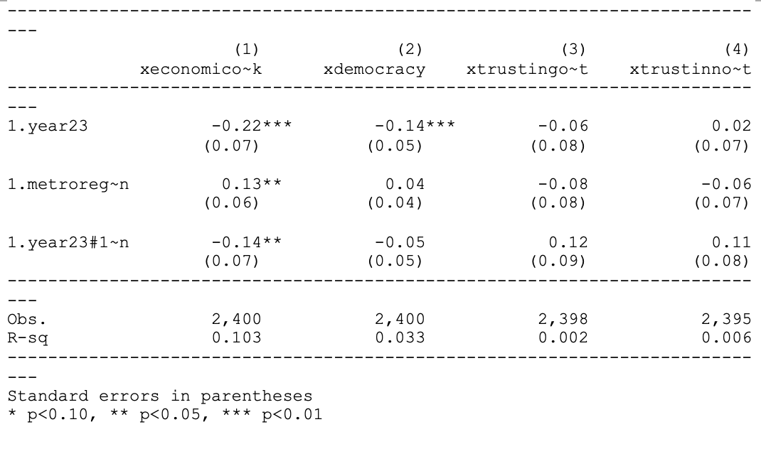

Table 2. Residential Differences in Economic Attitudes, Democratic Support, and Institutional Trust (2018 – 2023)

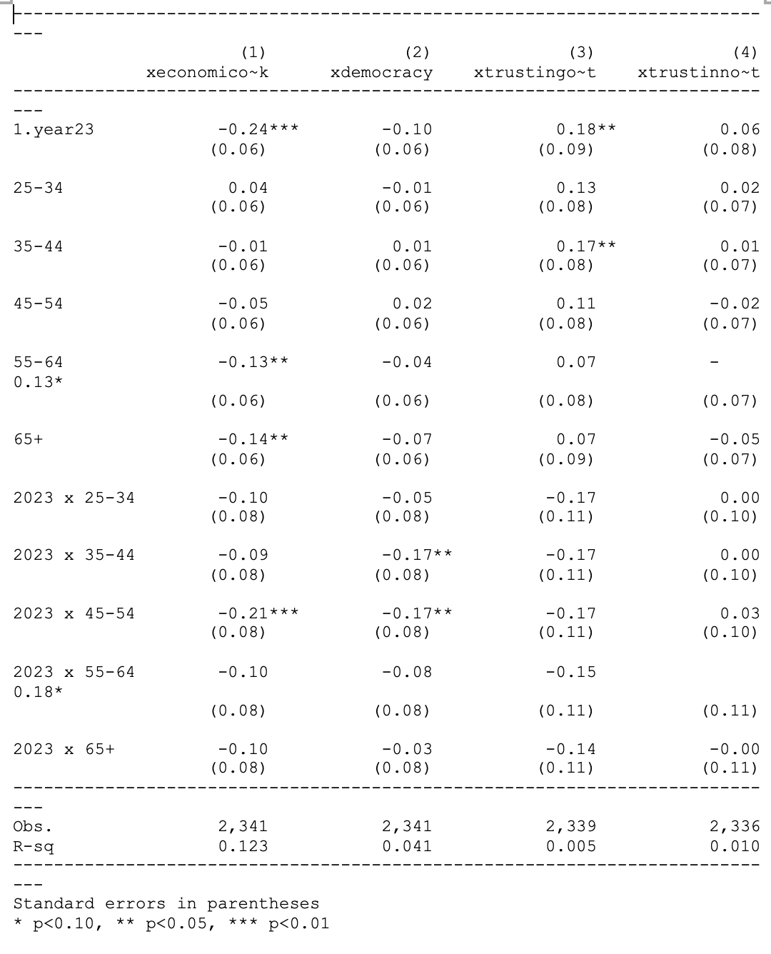

Table 3. Generational Differences in Economic Attitudes, Democratic Support, and Institutional Trust (2018 – 2023)

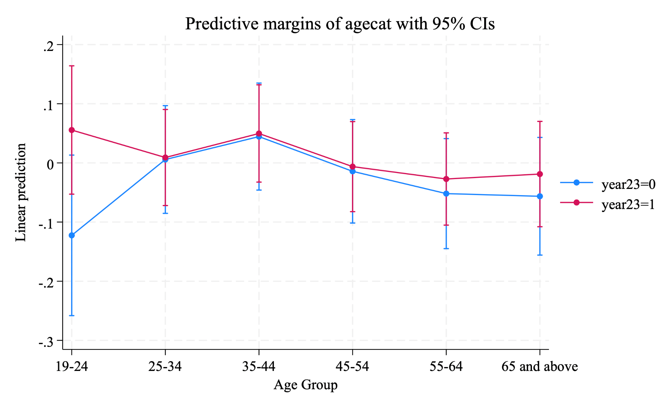

Figure 1. Predictive Margins of Institutional Trust by Age Group (2018–2023)

# 

Table 4. Political Belief Differences in Economic Attitudes, Democratic Support, and Institutional Trust (2018 – 2023)

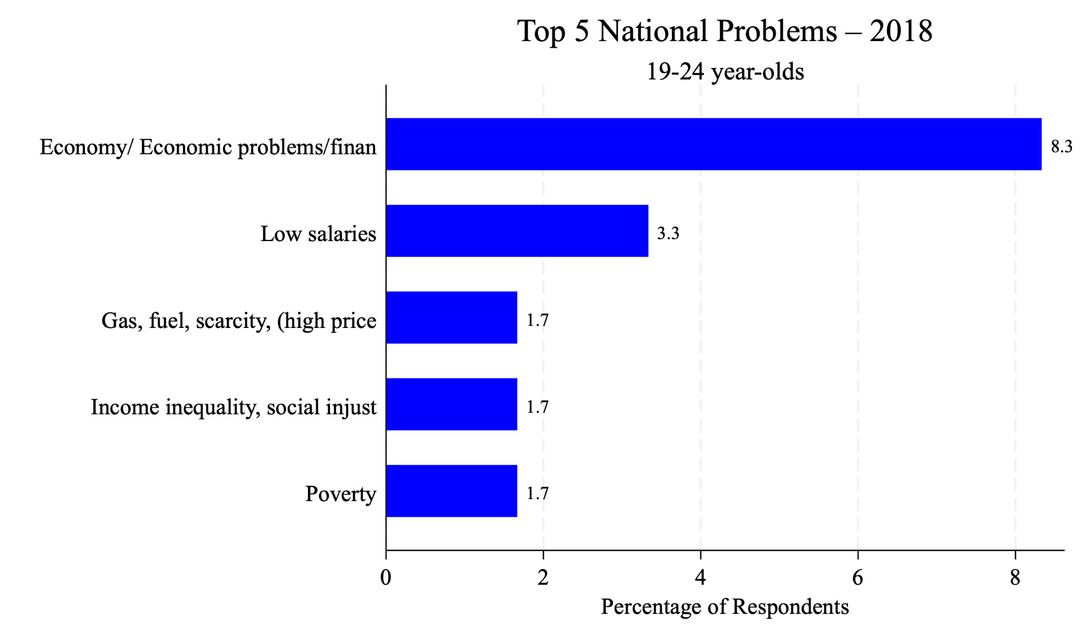

Figure 2. Top 5 National Problems in 2018 according to 19-24 year olds

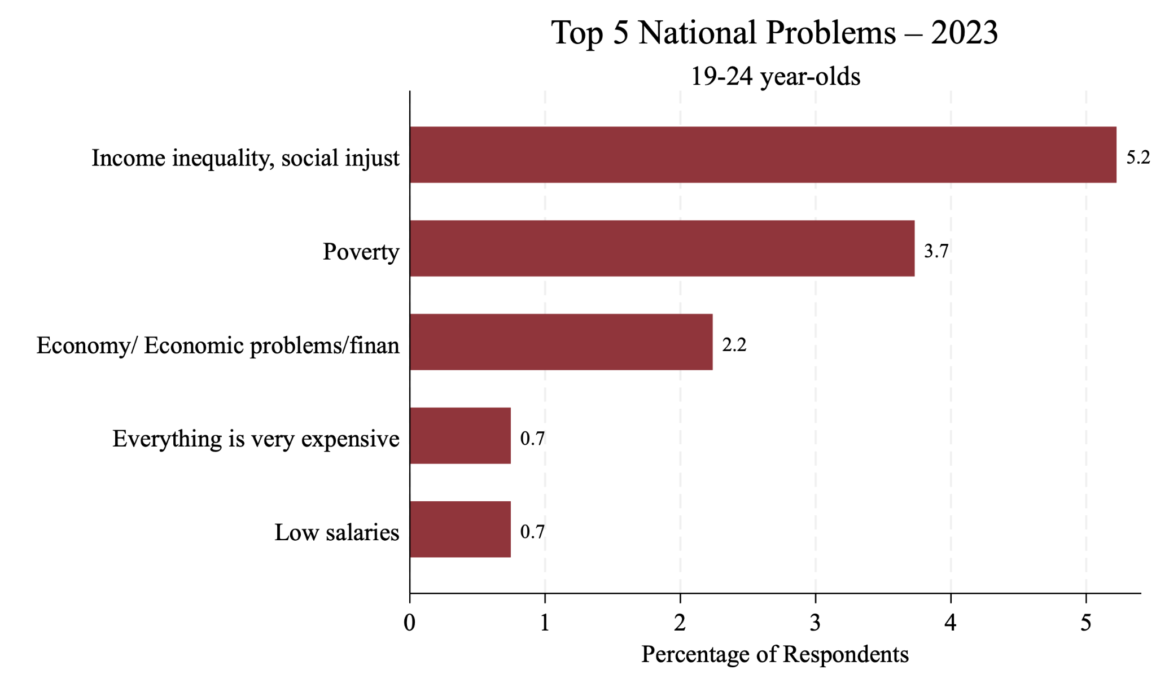

Figure 3. Top 5 National Problems in 2023 according to 19-24 year olds

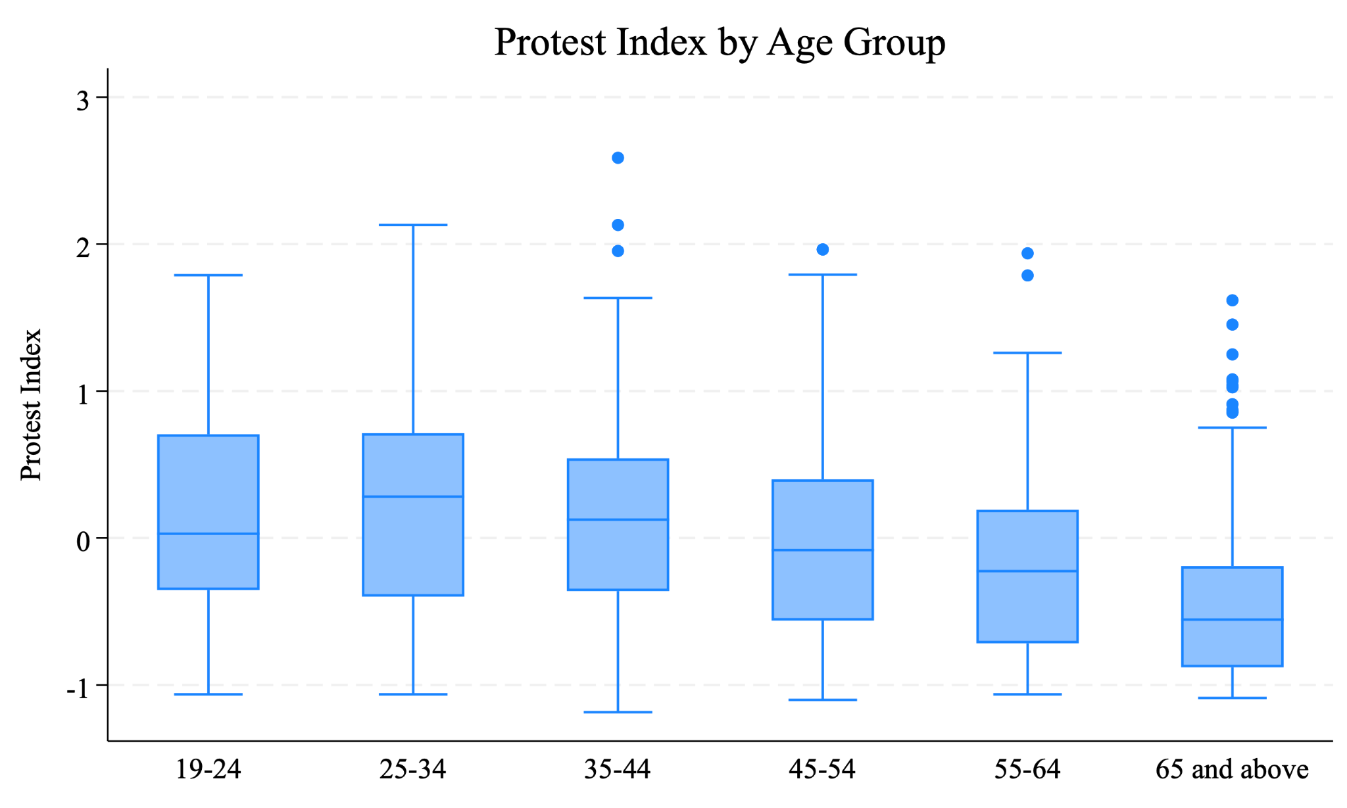

Figure 4. Protest Index by Age Group (2023)

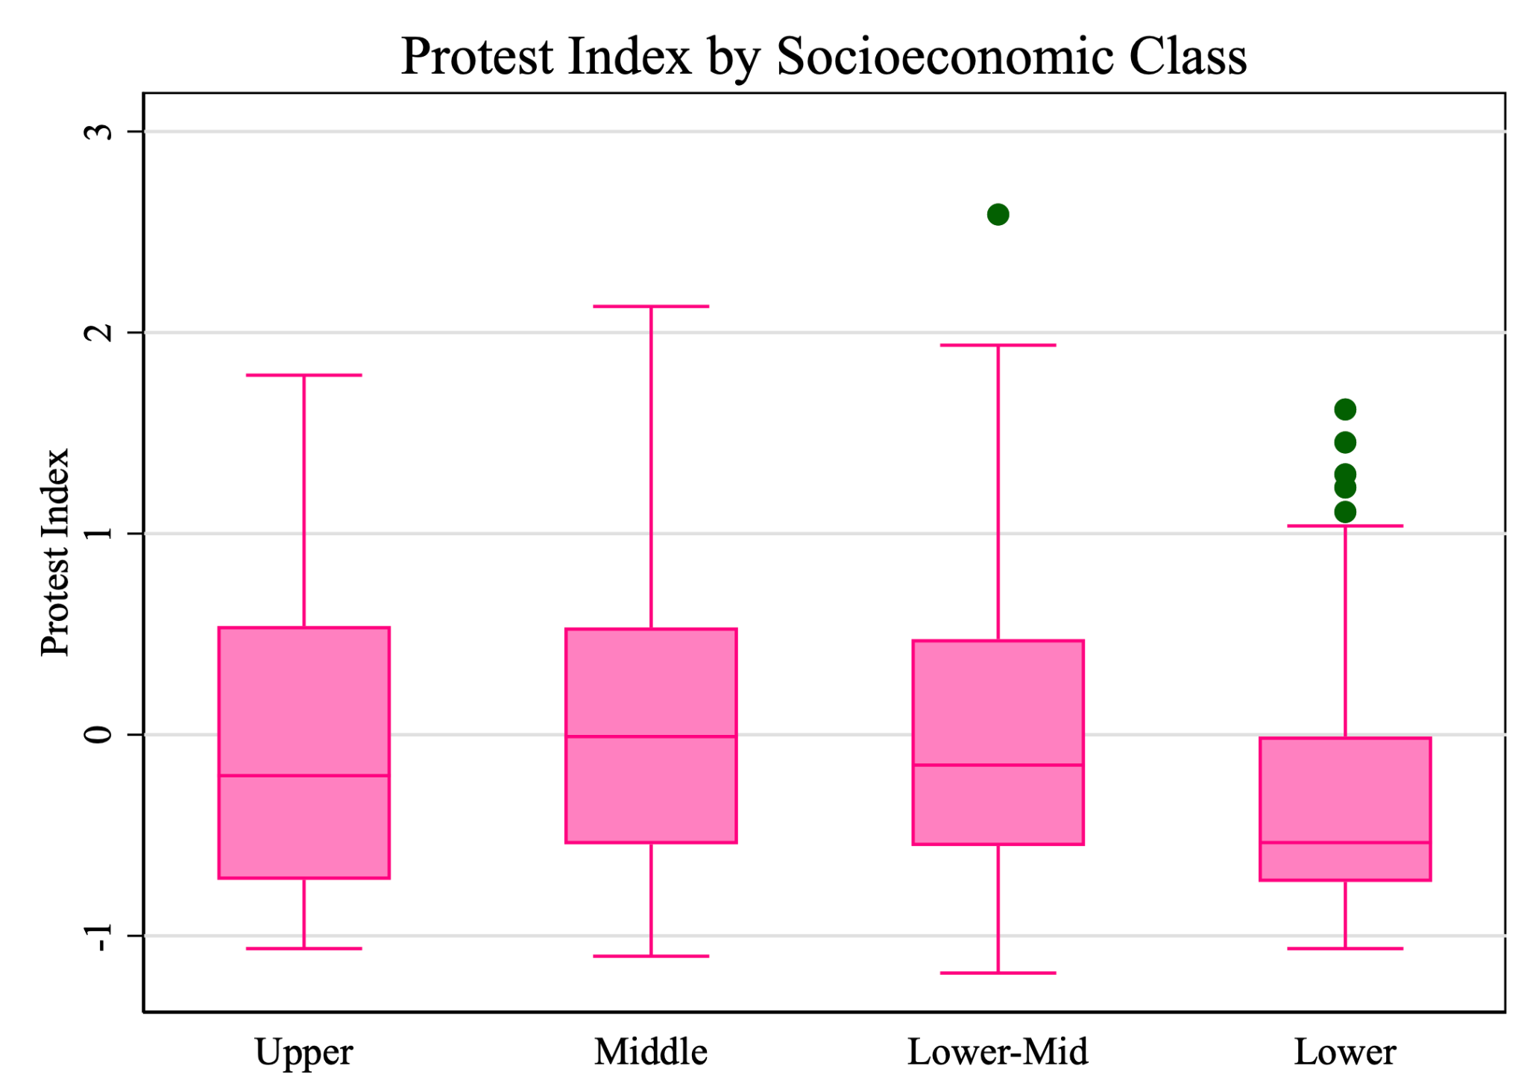

Figure 5. Protest Index by Socioeconomic Background (2023)

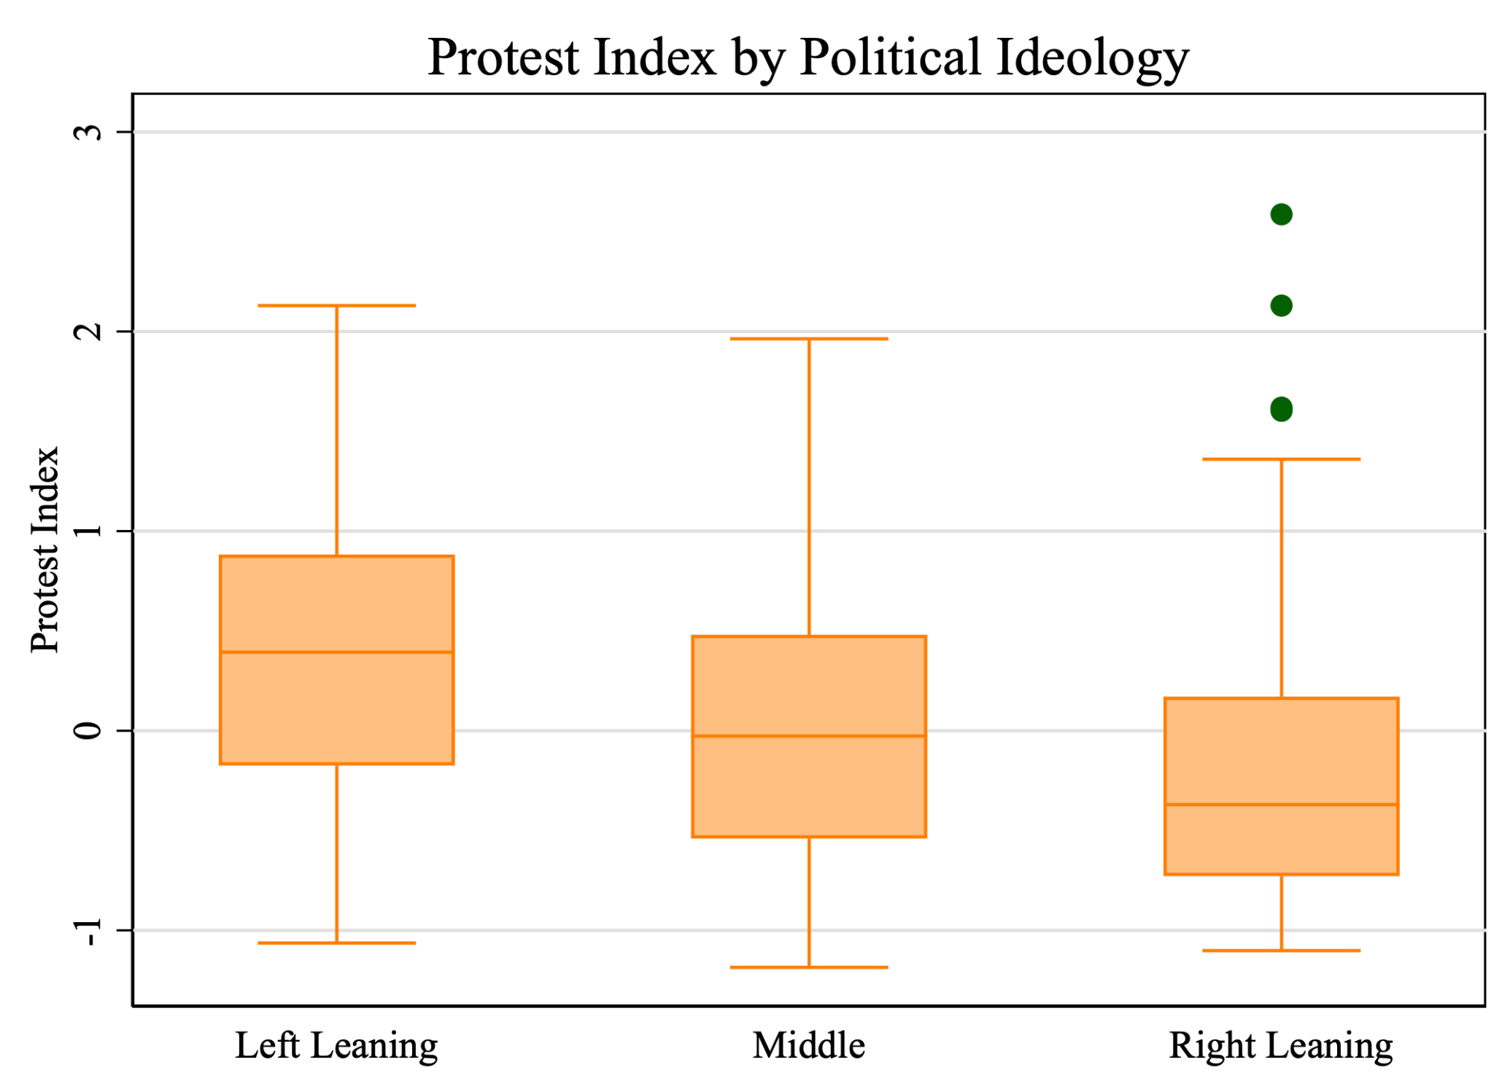

Figure 6. Protest Index by Socioeconomic Background (2023)